**Flappy Fish**

1. Delete Sprite 1 (the cat)
2. Add two variables Score and Speed making Score visible on the stage.
3. Paint a new Sprite (Sprite 1) as a bitmap. Also add the Bubbles sound from the sound library.

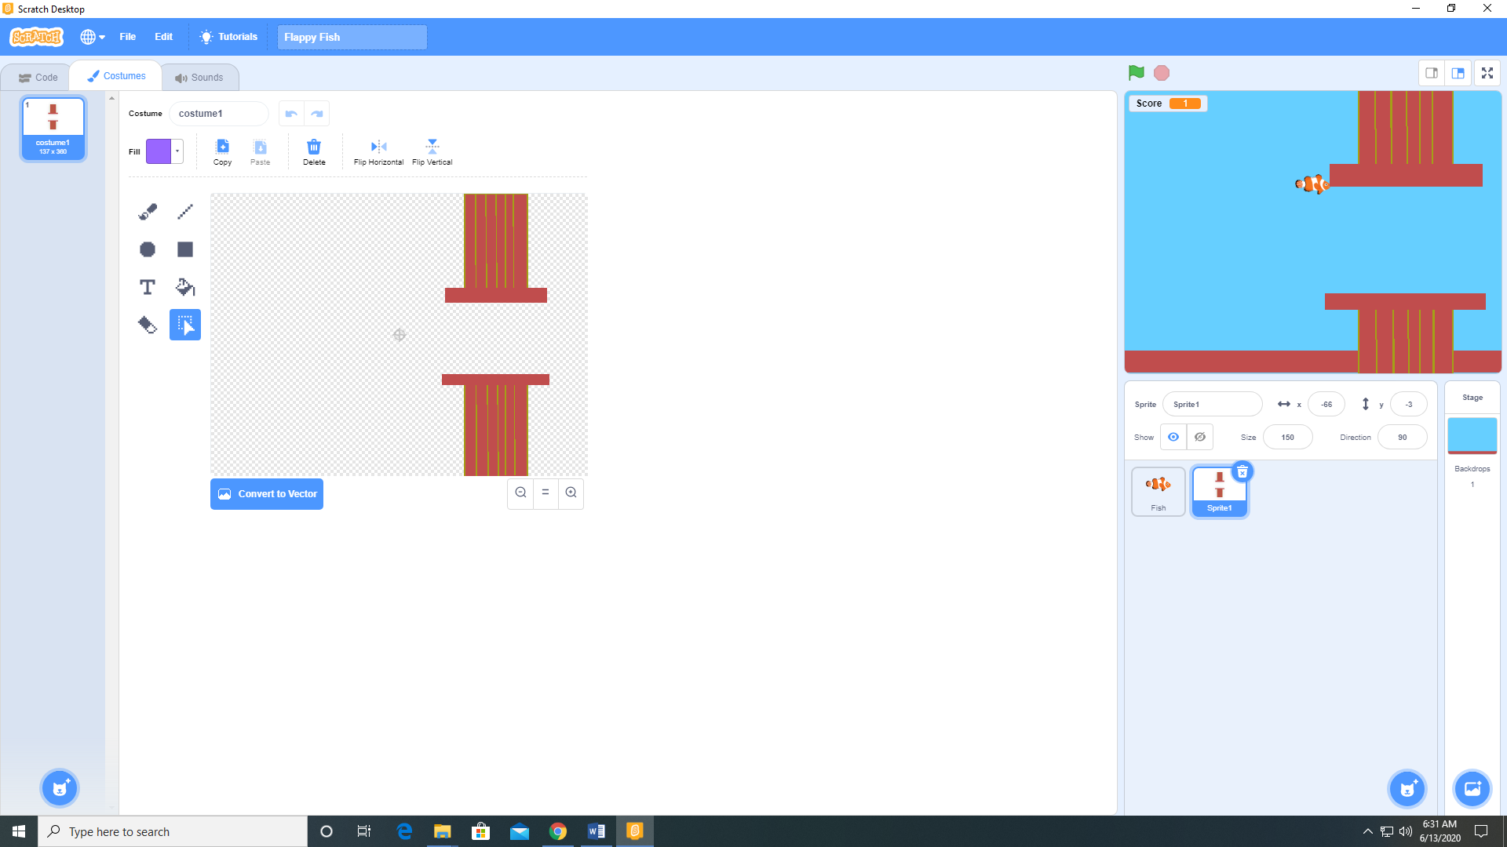

1. Add the Boing and Spooky String sounds to Fish sprite from the sound library. Add Bubbles sound to Sprite 1 from the sound library.

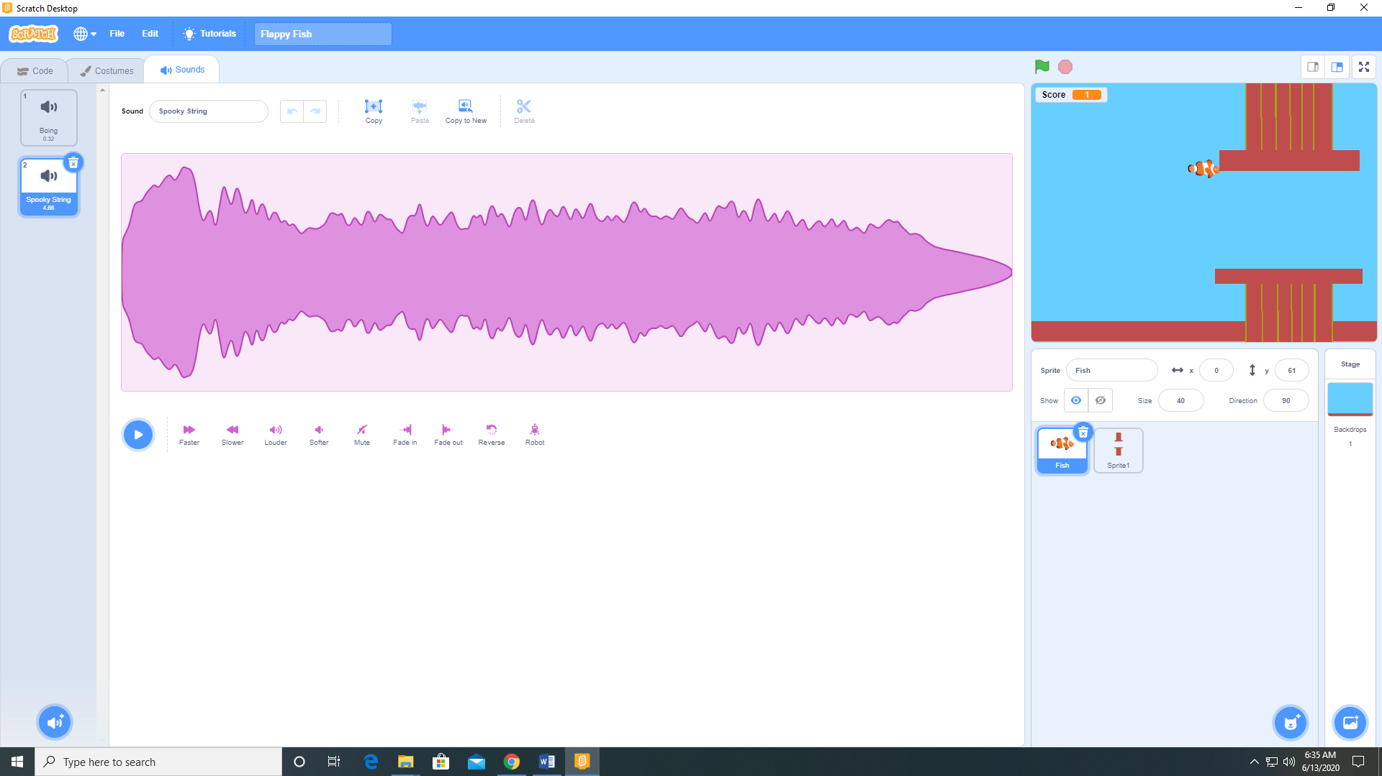

1. Add the following code to the Fish sprite.

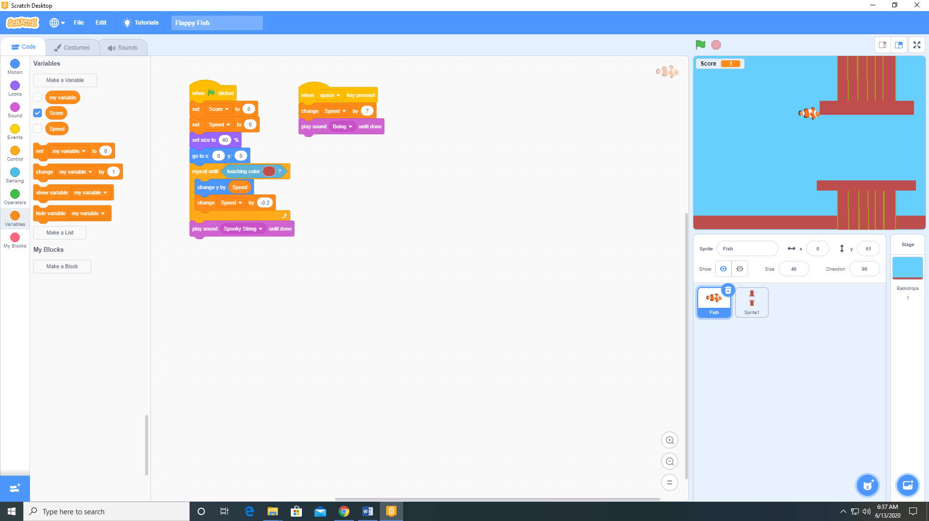

1. Add the following code to the Sprite 1 sprite.

